Microcontroller – CV RELATION:

If the face recognized → open the door
Change password → change the password on the ardunio

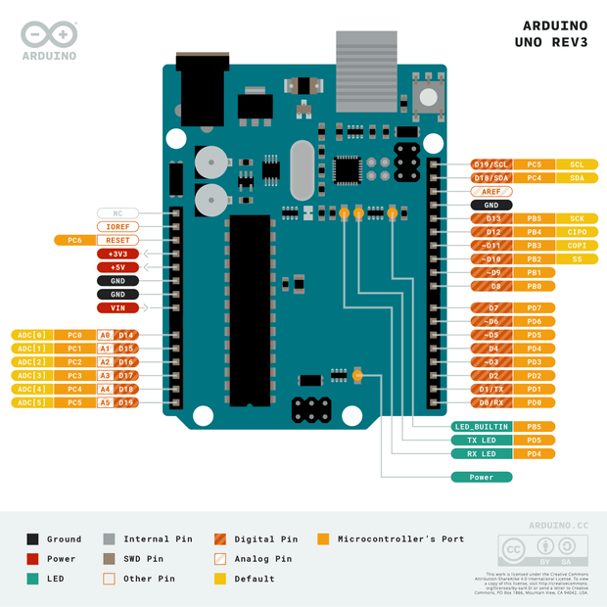
Microcontroller: TinkerCad’s ATMEGA328P
ATMEGA328P PDIP

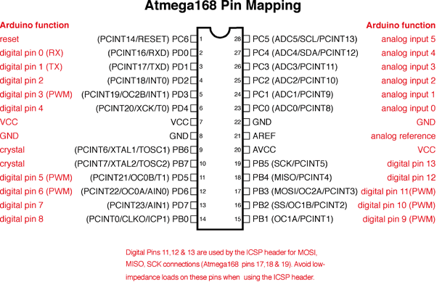

ATMEGA 8A PDIP

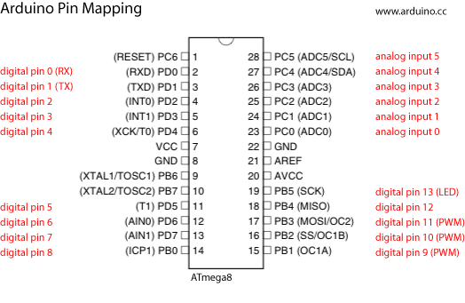

ATMEGA328P

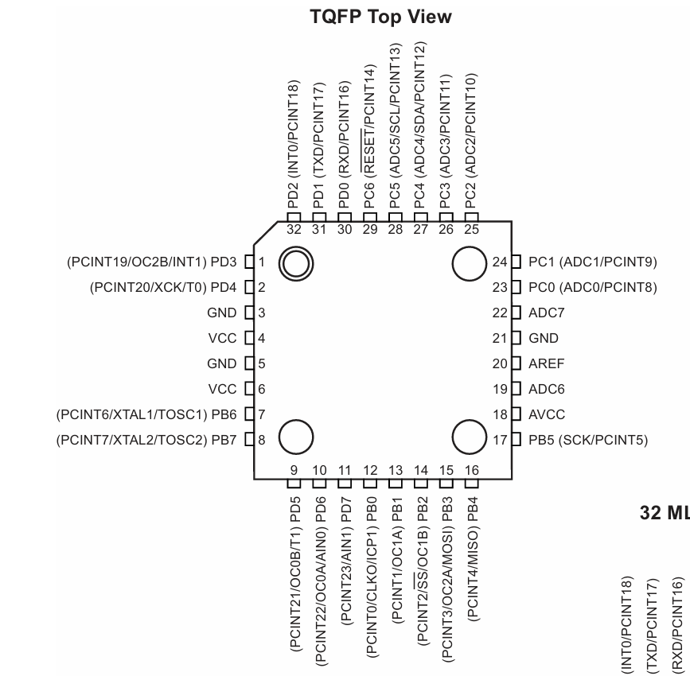

ATMEGA 8A

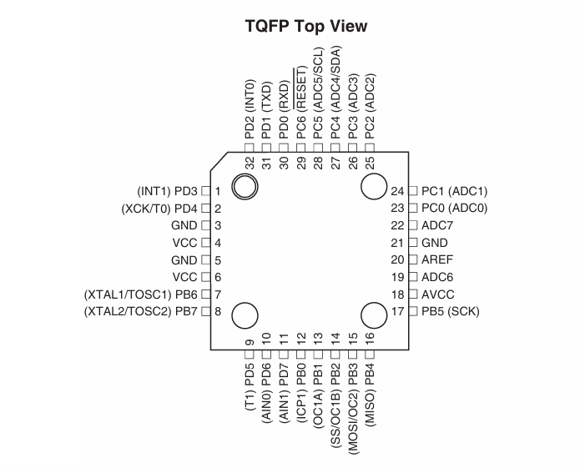

-ATMEGA328P Has 6 PWM channels while ATMEGA 8A only has 3 PWM channels
-Both has 6 ADC channels on PDIP package.

Components Links (Makers Store)

• Keypad : KeyPad 4×4 | Makers Electronics
• Buzzers : Magnetic Buzzer 5V 12mm 2 Pin | Makers Electronics
• Temperature sensor [NTC Thermistor Module] : NTC Thermistor 10KΩ | Makers Electronics
• PIR sensor : PIR Sensor SR501 | Makers Electronics
• LDR sensor : Photo Resistor Sensor LDR 7mm GL7528 8kΩ~20kΩ P=5mm | Makers Electronics
• RGB LED ; RGB Clear LED Common Cathode 5mm | Makers Electronics
• Motor + Fan Blades : DC Motor R280 3-12V 13750RPM | Makers Electronics , Plastic Propeller 4 Blades 100mm | Makers Electronics
• Driver L293D : L293D Quadruple Half-H Driver DIP-16 | Makers Electronics
• LED (as lighting system) : Oval Red LED 3.8x5mm | Makers Electronics
• Servo motor : Micro Servo SG90 0:180 Degree | Makers Electronics

Arduino
• ATMEGA 8A : ATMEGA8A-PU 8KB 2.7V~5.5V AVR 1KB 16MHz FLASH 23 DIP-28 AVR Microcontroller Unit | Makers Electronics

